**Project Design Phase-II Technology**

**Stack (Architecture & Stack)**

|  |  |
| --- | --- |
| Date | 16 October 2022 |
| Team ID | PNT2022TMID48024 |
| Project Name | Personal Expense Tracker Application |
| Maximum Marks | 4 Marks |

**Technical Architecture-**The Deliverable shall include the architectural diagram as below and the information as per the table1 & table 2 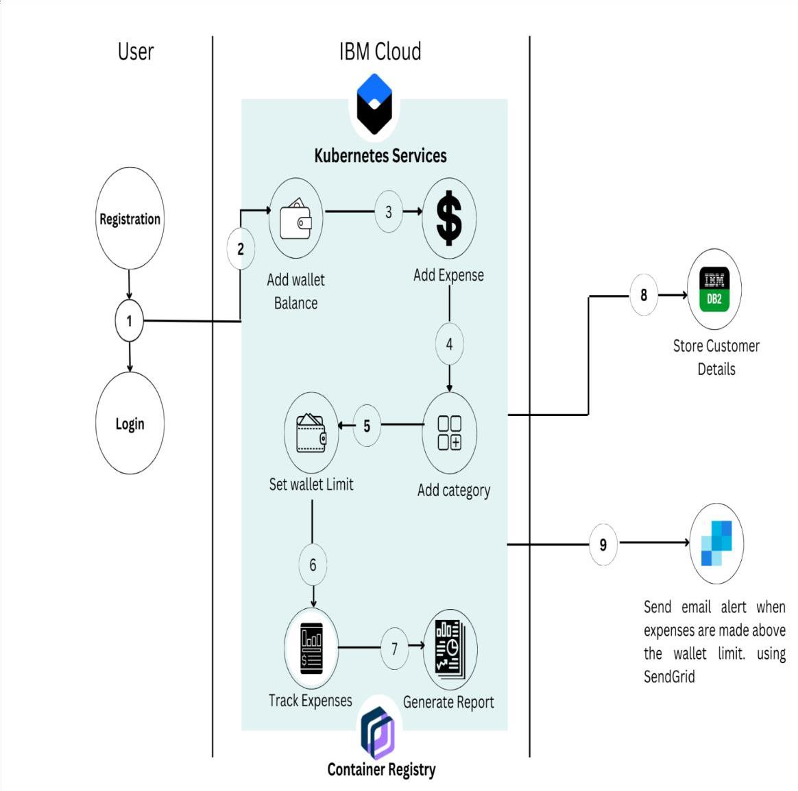

**Table-1 : Components & Technologies:**

|  |  |  |  |
| --- | --- | --- | --- |
| **S.No** | **Component** | **Description** | **Technology** |
| 1. | User Interface | How user interacts with application e.g. Web UI, Mobile App, Chatbot etc. | HTML, CSS, JavaScript |
| 2. | Registration and Login | To develop the application | Python, Docker |
| 3. | Wallet Dashboard | IBM Cloud Kubernetes Service provides a native Kubernetes experience that is secure and easy to use. This tool is used to load-balance, scale, and monitor the containers. | IBM Cloud Kubernetes Services |
| 4. | Tracking of Expenses. | IBM Container Registry enables to store and distribute Docker images in a managed, private registry. | IBM Cloud Container Registry |
| 5. | Database | Data Type, Configurations etc. | MySQL |
| 6. | Cloud Database | Database Service on Cloud | IBM DB2 |
| 7. | File Storage | File storage requirements | IBM Block Storage or Other Storage Service or Local Filesystem |
| 8. | External API-1 | To send email alerts when the expenses are made above the wallet limit. | SendGrid |

**Table-2: Application Characteristics:**

|  |  |  |  |
| --- | --- | --- | --- |
| **S.No** | **Characteristics** | **Description** | **Technology** |
| 1. | Open-Source Frameworks | Flask is an open source framework written in Python. | Flask |
| 2. | Security Implementations | The user accounts are configured to only allow access from users with specific privileges. | IBM DB2 |
| 3. | Scalable Architecture | Three-tier architecture- user server, application server and cloud server. | Python, IBM Cloud Services |
| 4. | Availability | Kubernetes services, the crudest form of load balancing traffic. The most basic type of load balancing is load distribution.The Docker load balancer runs on every node and can load balance requests across any of the containers on any of the hosts in the cluster. | Kubernetes and Docker |
| 5. | Performance | Can handle a large number of requests per second. | IBM Container Registry. |

**References:** <https://ieeexplore.ieee.org/document/9250969>

<https://www.cerdonis.tech/blogs/build-an-expense-tracking-app/>

<https://bootcamp.uxdesign.cc/expense-manager-application-ui-ux-case-study-the-dignitas-a6714900c60f>